P235/4
ISLAMIC
RELIGIOUS
EDUCATION
Paper 4
ISLAM IN AFRICA
AUGUST, 2019
2½ hours

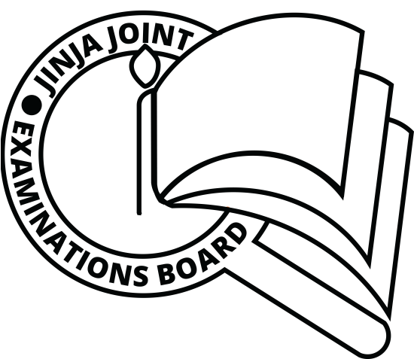

JINJA JOINT EXAMINATIONS BOARD

Uganda Advanced Certificate of Education

MOCK EXAMINATIONS – AUGUST, 2019

ISLAMIC RELIGIOUS EDUCATION

ISLAM IN AFRICA

Paper 4

2 hours 30 minutes

INSTRUCTIONS TO CANDIDATES:

This question paper is divided into two sections, A and B.

Answer any FOUR questions; selecting at least one from each section

ALL questions carry equal marks.

SECTION A
1. Assess the role of the coastal markets in the spread of Islam at the Coast of East Africa.
(25 marks)
2. (a) Discuss the factors that favored the Portuguese settlement at the east African coast. (13 marks)
(b) How did their settlement impact on the already existing Muslim community? (12marks)
3. How did Islam influence life of people of East African Coast in religion, social and moral aspects? (25 marks)
4. How far did the long distance trade facilitate the spread of Islam in interior of east Africa during the 19th Century? (25 marks)
5. Analyze the social- political conditions of Kenyan Muslims during the colonial period. (25 marks)

SECTION B:
6. To what extent did the similarities between Islam and African traditional religion facilitate the spread of Islam in West Africa? (25 marks)
7. Explain the ways through which the Ancient kingdom of Ghana was Islamized.
(25 marks)
8. Examine the strength and weaknesses of the Berbers to the spread of Islamic culture in West Africa. (25marks )
9. How far was Mansa Musa responsible for the development of Islamic culture in Mali kingdom? (25 marks)
10. “The Al-moravids were primarily responsible for the struggle to bring about the growth and development of Islam in West Africa “Discuss (25 marks)
11. To what extent did the Suffi Tariqas contribute to the consolidation of Islam in West Africa? (25 marks)
12. (a) Why did the 19th century Jihad movements in West Africa break out? (13 marks)
(b) How did these movements contribute to Islamic progress in the Region?
(12 marks)

